Assignment: 6

Name: Divya Shah Branch: IT/V Roll No.: 115 Date:26/08/2023

**Aim:** To build pipeline using Jenkins.

**LO mapped:** LO1, LO3

**Theory:**

* Setting up Jenkins

Set up the Jenkins before pipeline development

* Creating Jenkins Pipeline

A Jenkins pipeline defines the entire build process, from retrieving the source code to building, testing, and deploying an application. There are two primary ways to create Jenkins pipelines: Declarative and Scripted.

**Types of Jenkins Pipelines:**

* Declarative Pipeline: This type of pipeline uses a simplified and structured syntax, making it easier to read and write. It's recommended for beginners and is a great choice for most use cases.
* Scripted Pipeline: Scripted pipelines are more flexible and powerful but use a Groovy-based DSL (Domain Specific Language). They are suitable for complex or customized build processes but require a deeper understanding of Groovy scripting.
* Follow the Steps to make a pipeline in Jenkins

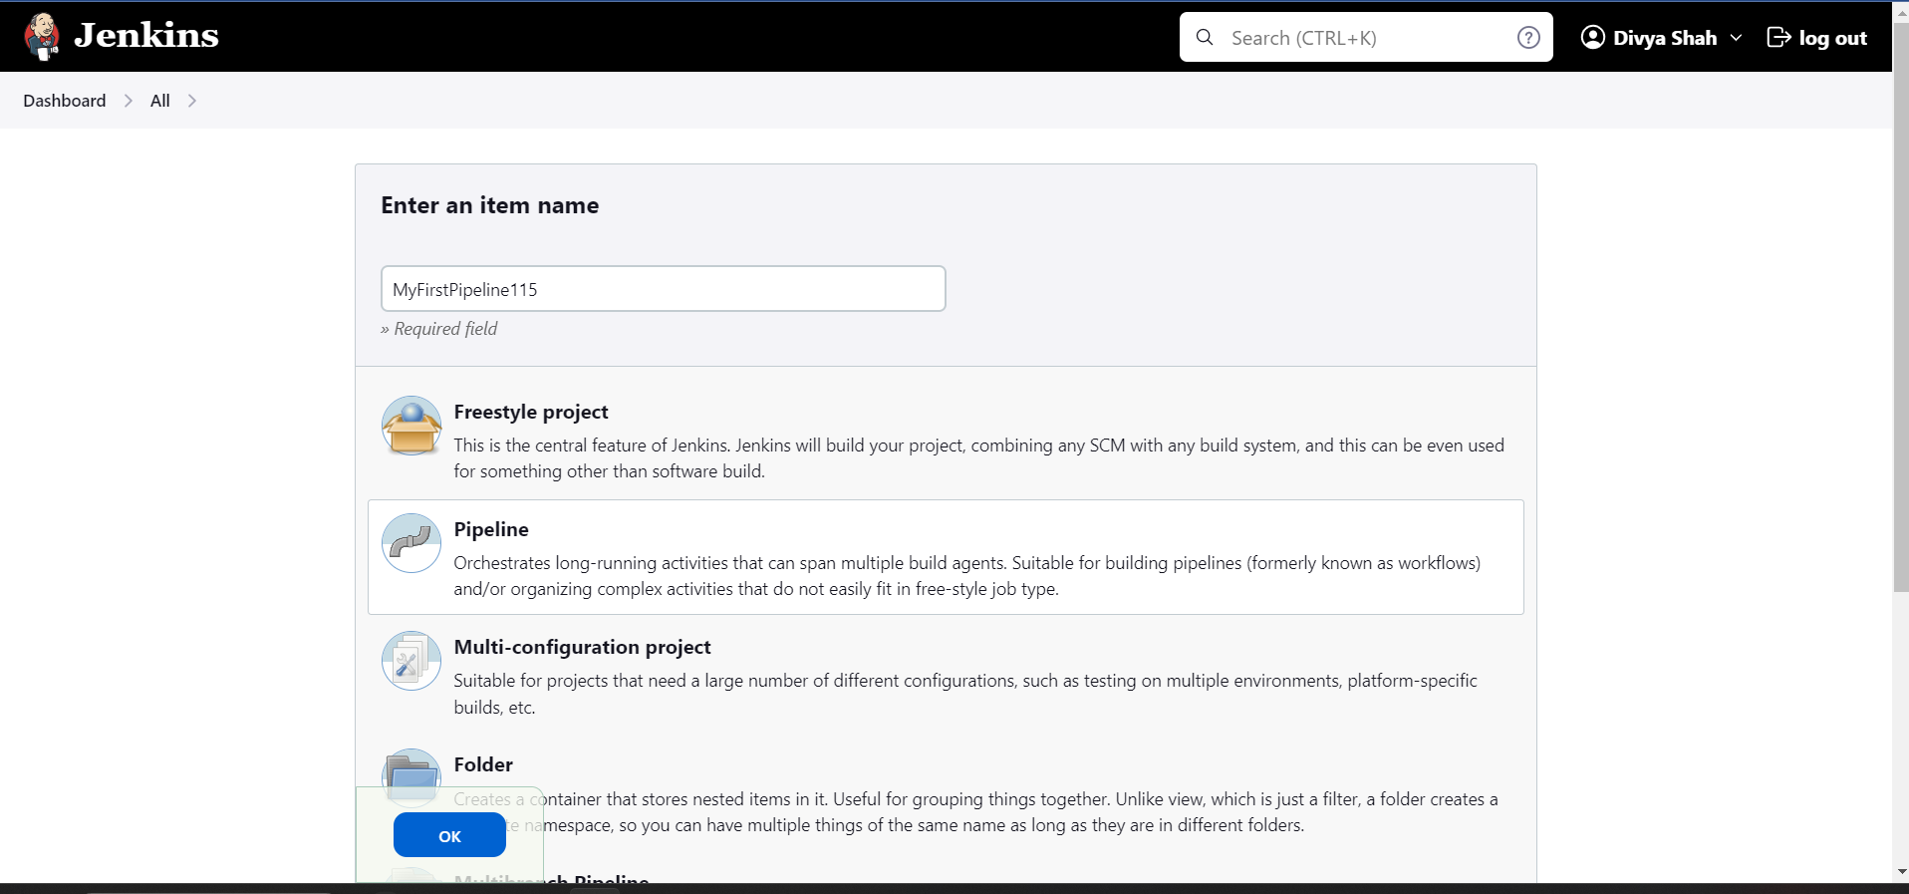

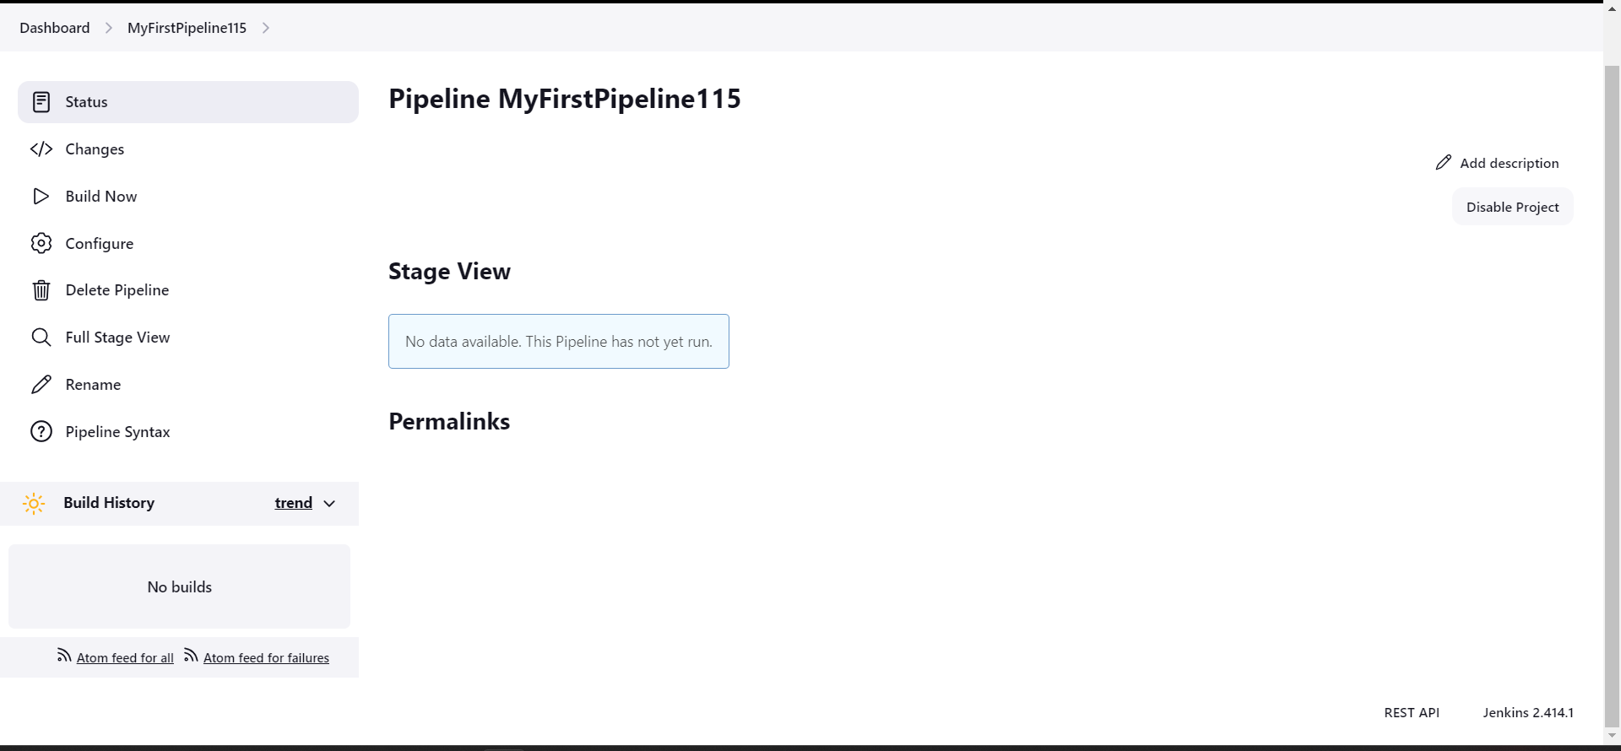

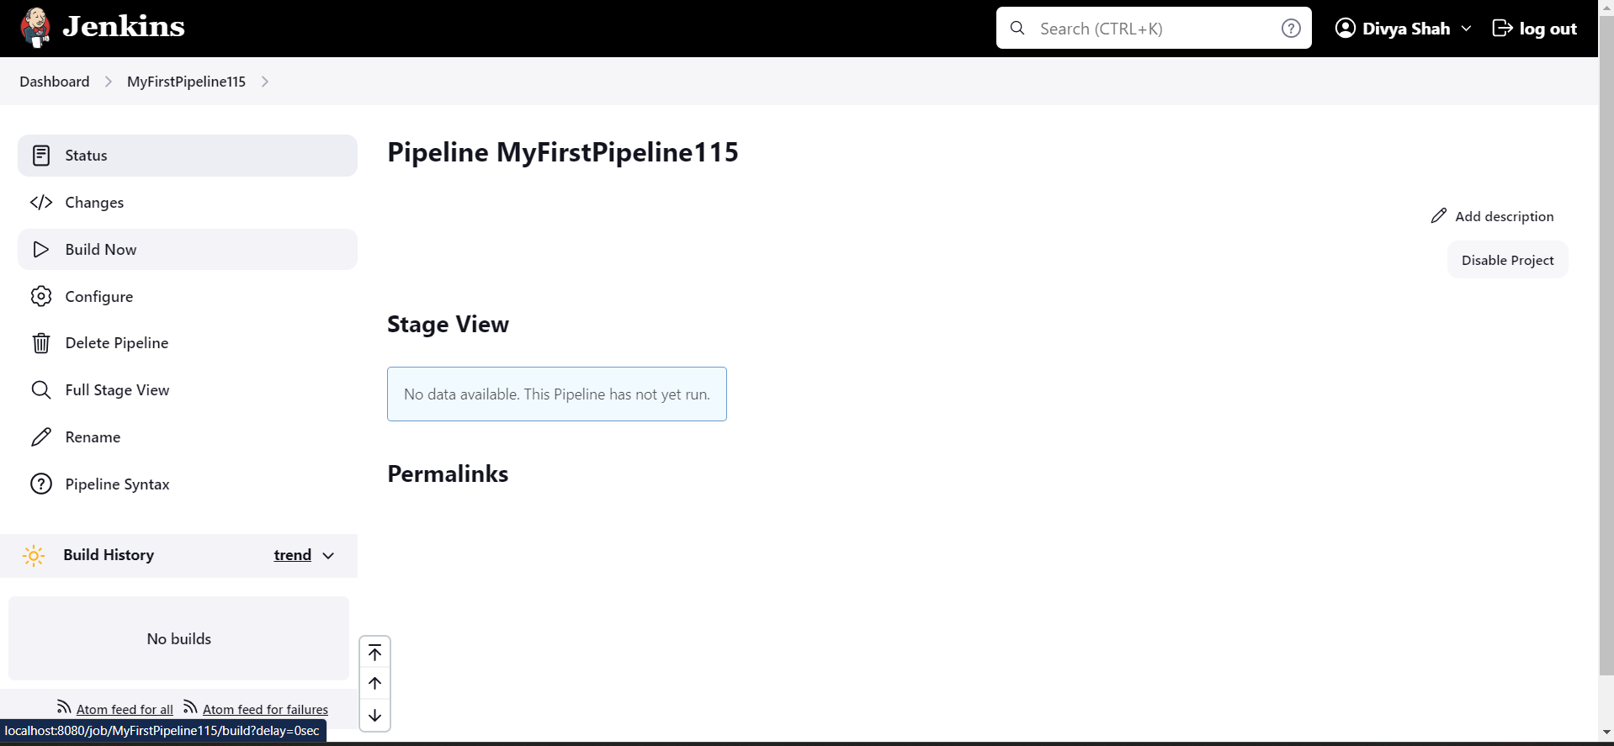

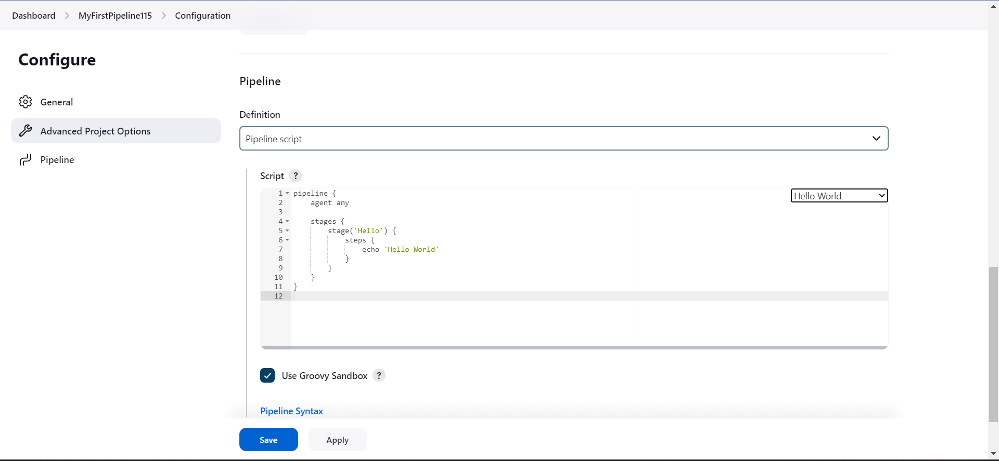

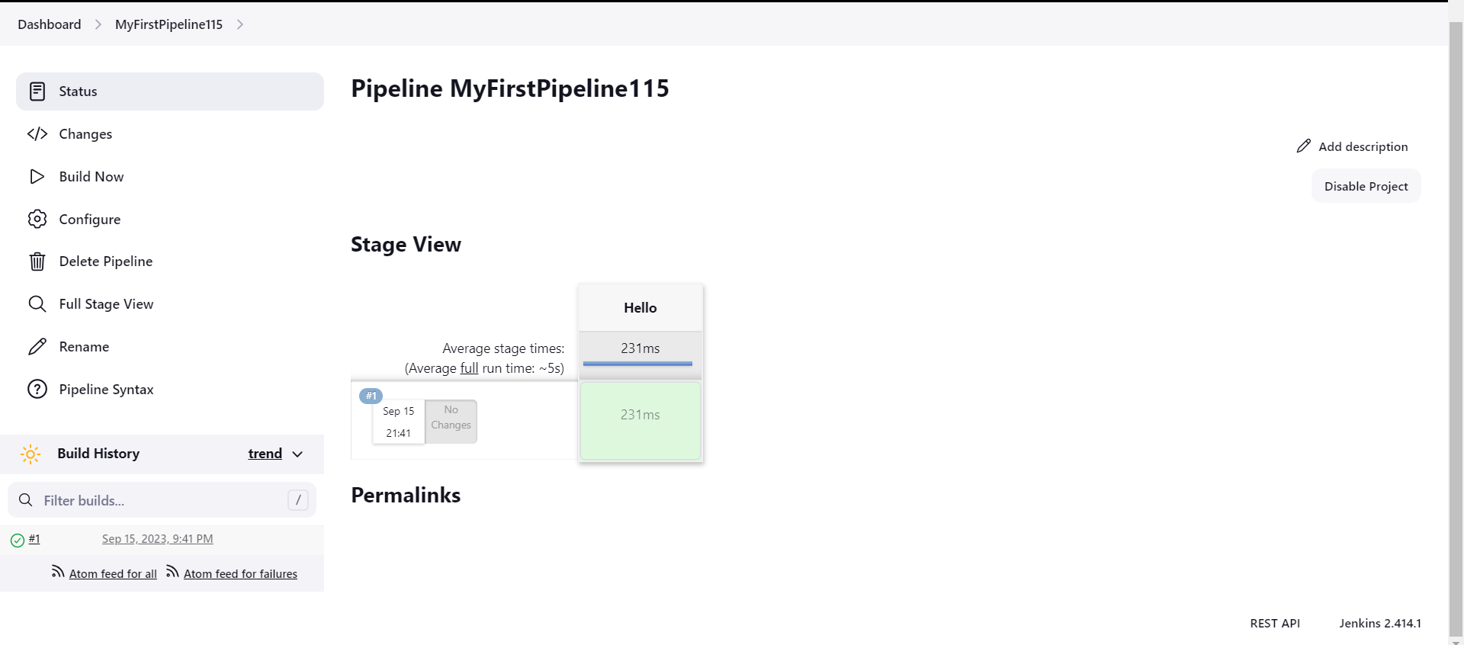

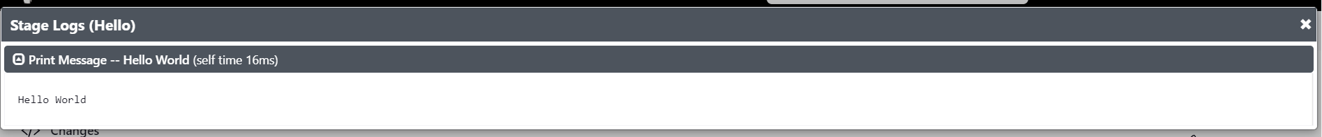

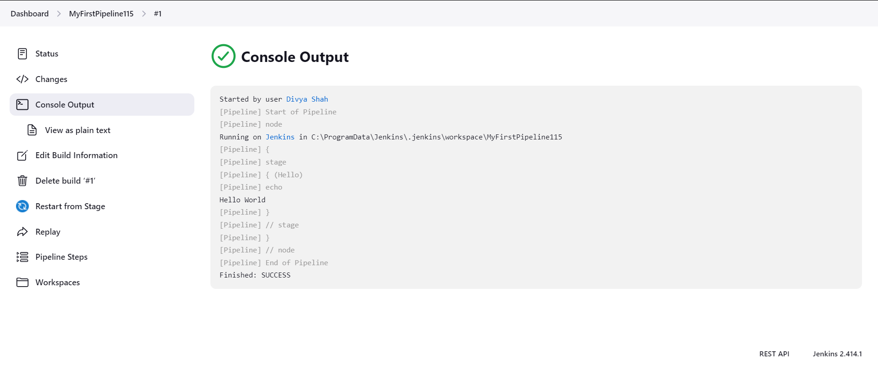

**Conclusion:** By this assignment we build pipeline using Jenkins.